**SUMMERHALL ARTS**

**FESTIVAL FRINGE INFORMATION PACK**

***2025***

***Previews:*** *Thur 31st July*

***Festival:*** *Fri 1st - Mon 25th Aug*

***Days Off:*** *Mon 11th & 18th Aug*

1 Summerhall, Edinburgh, EH9 1PL

info@summerhallarts.co.uk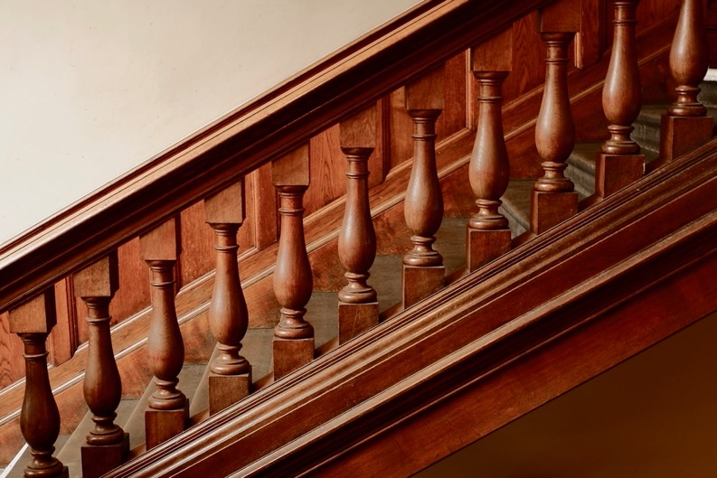

**About**

Summerhall Arts was set up in October 2023 as an independently governed and financed charity (SC052638) to support the arts and culture sector. Its primary ambition is to offer year-round creative opportunities and professional development to the arts practitioners of Scotland. It is delighted to be able to now deliver a fringe festival programme in such an important venue. It aims to build on the legacy created by its predecessor, Summerhall Management LTD, that won multiple awards in its thirteen years as a festival and year-round venue, providing a safe and supportive space for artists. We will continue to champion high-quality, contemporary work that says something about the world and does it in an interesting way - offering continuity of quality through the expertise of the previous programming and delivery teams.

Summerhall Arts feels strongly that the work it aims to support throughout the year, via a diverse programme of activity, is housed within a venue that has a strong reputation for this type of work - both in the visual and performative arts. Whilst this will be our first fringe we hope you as artists, and our audiences experience a continuity in our shared ambition to support the artists and work to showcase their talent on the world stage.

We are dedicated to supporting the artists, companies and producers that we work with. We value the creative process, and support people at every stage of their career: from emerging and independent artists to major national portfolio companies.

The building's history as a former veterinary school makes itself felt in the wide variety of performance spaces, each with their own charm. Summerhall is a rich community of over 100 businesses, including its own pub, a brewery, distillery, cafe, escape rooms, artists, printers, animators, photographers, a hairdresser, and a wonderful buzzing festival courtyard.

Summerhall Arts is governed by a diverse, experienced and professional board from the arts, education, health and wellbeing, broadcast, financial and legal sectors. It is led, driven, and delivered by an experienced team of arts and festival professionals.

We believe in challenging the status quo of the wider festival to the same level expected of artists by their audiences.

**Access**

All of our venues are accessible. We welcome D/deaf and disabled customers and is committed to improving access to the building, exhibitions, performances and events. The building has achieved Level Two (of 3) of the Edinburgh Festival Fringe Society’s Venue Access Award. This pack includes access information for all our performance spaces. We are keen to work with visiting companies who wish to present accessible performances. The Fringe Society’s website has useful information about including accessible performances in your Fringe run. [Click here to learn more.](https://www.edfringe.com/take-part/putting-on-an-accessible-show)

**Fair Work**

Summerhall Arts supports the five principles of the Fair Work Framework. All employees - permanent and seasonal - are paid at least the equivalent of Real Living Wage or above.

**Sustainability**

Summerhall Arts is doing its best to minimise the environmental impact of the festival. We are Edinburgh’s only flyer free venue, have space for 70 bikes on site and you’ll find recycling facilities across the campus.

**Venues**

Summerhall Arts is uniquely situated in a one hundred year-old veterinary school. We have spaces with a municipal feel, spaces with a post-industrial or medical feel, and spaces with a grand period feel.

**Main Hall** (MH)

For the Festival, the Main Hall seats an audience of 146 in traditional end-on format, and makes for a smart and flexible studio theatre. This space is accessible by lift.

***Stage****:* ***7m wide x 6m deep*** *plus very limited wing space covered in black vinyl dancefloor.  
5.8m**clearance to bottom of truss structure.*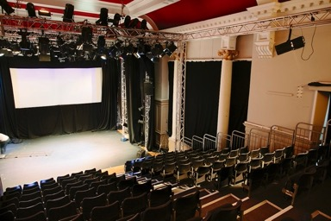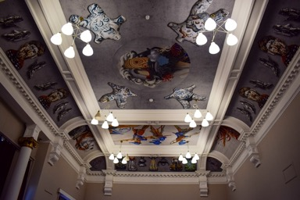

**Red Lecture Theatre** (RLT)

A cosy 70s lecture theatre complete with red lacquer tables and flip down seats. This space works well for performances using projection and is also a great space for more intimate shows where the performers need a close connection with the audience. There is a small projection/sound booth at the rear of the auditorium. This venue is accessible by lift. Capacity: 80

***Stage****:* ***8.0m x 3.3m*** *flat floor covered in black vinyl dancefloor. Height to ceiling: 3.5m (approx. 2.8m clearance to light fixtures). The front row of seats is adjacent to the stage, if filled these will reduce usable stage depth by approx. 60cm.*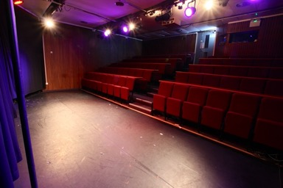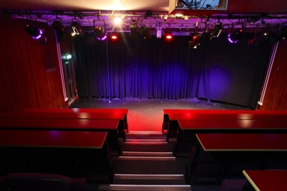

**Anatomy Lecture Theatre** (ALT)

An intimate room with a raised wooden horseshoe seating area. As well as offering a special atmosphere, it’s also a very functional performance and storytelling space, not least for the immediacy brought about by the height of the rake: actors tend to be at eye level with the front row. Capacity: 58. There is unstepped access to this space.

***Stage: 8.30m x 2m stage with 3.4m x 3m thrust.*** *On flat floor covered in black vinyl dancefloor. Ceiling: 4.4m clearance.*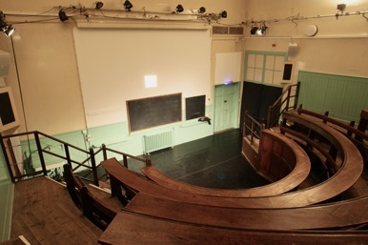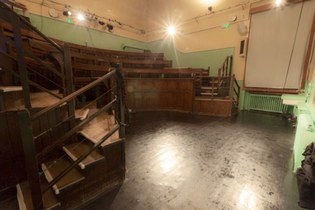

**Demonstration Room** (DEMO)

Similar seating to the Anatomy Lecture Theatre, but with a completely different atmosphere: the Demonstration Room is a stark and uniquely atmospheric space that gives audiences a powerful experience before the work even starts. There are 5 aerial points in the space, plus ground level points suitable for Chinese pole. Capacity: 58. There is unstepped access to this space.

***Stage: 7.8m x 3.7m with 5.3m x 2.3m*** *thrust**on flat floor. Covered in black vinyl dancefloor. Height: 6.0 m max clearance.*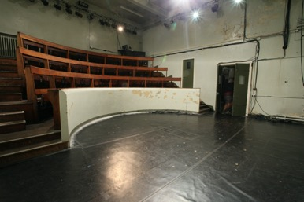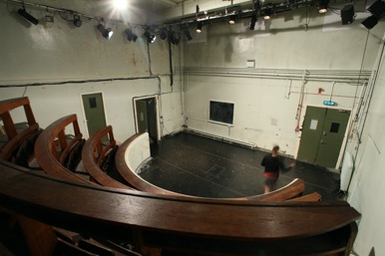

**TechCube0** (TC0)

TC0 (TechCube 0) is in horseshoe configuration with the largest projection area capability of all of our venues and seats 114. Exceptionally flexible with a great capacity for projection, this space allows for an innovative approach to intimacy that feels both unobtrusive yet accessible for participation and engagement. There is unstepped access to this space.

***Stage 6m x 5m*** *covered in black vinyl dancefloor. 3.1m height clearance across most of the stage.*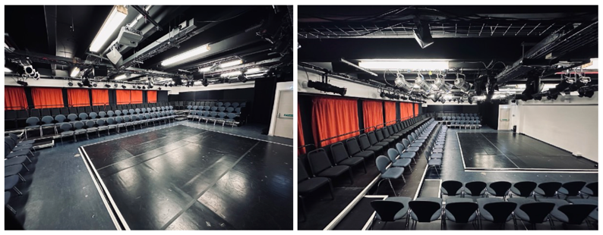

**Basement/other spaces**

The venue is able to accommodate work which doesn’t fit easily into the typical Fringe slot. We have some spaces which can be used for installed or durational work – if you have a show which you think fits our programme but doesn’t fit our spaces then please do apply and we’ll see what we can do!

**Offsite**

We are also happy to work with companies to present suitable work at venues outside the Summerhall site.

**To be further announced,** Summerhall Arts are currently working on additional spaces within the building. Confirmation of their availability will be announced and allocated as soon as we are able to. For those that know the building, amongst others, these spaces include the Cairns Lecture Theatre and the Old Lab.

**Financial**We have two deal strands that the company can choose from once we have decided that the show is a good fit for the Summerhall Arts programme: **Full-Hire Agreement** or a **Box Office Split**.

| Full-Hire Agreement | | | | | | |
| --- | --- | --- | --- | --- | --- | --- |
| The venue is paid a Full-Hire Fee. The company take 100% of box office sales and decide their own ticket pricing. | | | | | | |
| *Venues* | Seated Capacity | Full-Hire Fee | Box Office Split* | Marketing Contra | Early Bird EdFringe Registration Fee | Upfront Cost |
| ALT | 58 | £5,500.00 | 100% | £350.00 | £246.00 | £6,096.00 |
| DEMO | 58 | £5,500.00 | 100% | £350.00 | £246.00 | £6,096.00 |
| RLT | 80 | £7,500.00 | 100% | £500.00 | £246.00 | £8,246.00 |
| TC0 | 114 | £9,000.00 | 100% | £650.00 | £246.00 | £9,396.00 |
| MH | 146 | £12,000.00 | 100% | £750.00 | £246.00 | £12,996.00 |
| All costs listed are exclusive VAT. *100% of ticket sales in favour of the company. On the Full-Hire Agreement, The EdFringe Box Office Commission is *5%*, and the Summerhall Arts Box Office Commission is *8%*. Typically, 70% of ticket sold are through the EdFringe Box Office and 30% through the Summerhall Arts Box Office. | | | | | | |

The full-hire agreement gives **100% of the ticket revenue** to the artists. It allows companies that expect a higher sales count to take greater control and ownership of their stake in a festival run. If, for example, a company wants discounted tickets for a specific target audience; unlimited complimentary ticket allocation for industry guests; dynamic pricing to help make a Fringe-run more viable for larger productions, then this strand is a good option to explore.

With 100% of sales going to the company at the end of the festival, the venue will charge a non-returnable amount up-front, in two chunks. While the company has majority control of their ticket pricing on this strand, the venue will ensure that pricing doesn’t disadvantage other companies.

We appreciate that this approach won’t suit all shows,  so it will also continue to offer the more traditional fringe model. The conventional Fringe deal is based on a split of the box office income 60% (to the show) and 40% (to the venue) versus a minimum guarantee to the venue. Summerhall Arts will retain the pre-paid guarantee or 40%, whichever is greater at the end of the festival.

Summerhall Arts is delighted to be able to freeze the minimum guarantee figures from 2024 into 2025.

Both deal strands also require a contribution towards marketing costs and you will need to pay for any technical equipment beyond the standard spec of the space.

| Box Office Split | | | | | | |
| --- | --- | --- | --- | --- | --- | --- |
| Using a ticket price chosen by the venue, £15, Summerhall Arts’ venue fee will either be 40% of the Box Office or the Minimum Guarantee, whichever is the greater amount. | | | | | | |
| *Venues* | Seated Capacity | Minimum Guarantee | Box Office Split* | Marketing Contra | Early Bird EdFringe Registration Fee | Upfront Cost |
| ALT | 58 | £3,000.00 | 60/40 | £350.00 | £246.00 | £3,596.00 |
| DEMO | 58 | £3,000.00 | 60/40 | £350.00 | £246.00 | £3,596.00 |
| RLT | 80 | £4,000.00 | 60/40 | £500.00 | £246.00 | £4,746.00 |
| TC0 | 114 | £5,000.00 | 60/40 | £650.00 | £246.00 | £5,896.00 |
| MH | 146 | £6,000.00 | 60/40 | £750.00 | £246.00 | £6,996.00 |
| All costs listed are exclusive VAT. *In favour of the company. The EdFringe Box Office Commission is *5%*, and in the Box Office Split deal strand, Summerhall Arts Box Office Commission is *4%*. Typically, 70% of ticket sold are through the EdFringe Box Office. | | | | | | |

Both Summerhall Arts and the Fringe Society charge a base fee for ticketing equipment and credit card services of the gross box office (SH Arts 4% & EdFringe 5%), which will be deducted before the split is calculated. However, the Summerhall Arts Box Office Commission is 8% on the Full-Hire Agreement because busier shows are more expensive to sell for in terms of staffing and in-person customer volume. We typically receive settlement statements from the Fringe and Summerhall Arts box office providers by the end of September, and aim to have all accounts cleared with companies by the end of October.

The guarantee, full-hire fee, marketing contribution and Fringe Registration Fee are payable in advance – 10% of the guarantee/full-hire fee is paid at the time of offer to reserve the slot, and the remaining 90% is due by the end of May. If this represents a cashflow issue for you and you need a structured payment plan then please ask. Additional technical equipment must also be paid for in advance. If payments are not received by the agreed dates, your slot may be offered to another company.

At the end of the festival we will total your EdFringe and Summerhall Arts Box Office receipts and calculate the split. We will then pay you your share of the box office, less any amounts still owing to Summerhall Arts.

**What is included in a deal**

* + Your timeslot within the venue’s programme.
  + Staffing and sales via our box office system, which is linked to the Fringe box office.
  + We will register your show in the Edinburgh Festival Fringe Programme, recharging you at cost for the Fringe registration fee.
  + Press and marketing support for the programme as a whole, not specifically for your show.
  + Technical support to get your show in, but not to operate.
  + A basic level of technical equipment as detailed in the venue specifications.
  + Shared use of dressing rooms and (very limited) storage.

**What is not included in a deal**

* + Fringe Society registration fee – see https://www.edfringe.com/take-part/putting-on- a- show/registration for current rates.
  + Additional technical support or technical equipment hires, beyond those that come as standard in the venue.
  + Additional time in the venue for set-up or get-out additional to that which is part of the contract.
  + The Marketing Contra which finances the brochure design, print and distribution.
  + There is also a separate charge if you wish to hire out our PR team.
  + Charges for the use of music in your show levied by PRS/PPL. Click here to learn more.

**VAT**

VAT (Value Added Tax) is a UK tax on goods and services. VAT will therefore be charged on all relevant invoices from Summerhall Arts. If you’re on a Box Office Split deal, Summerhall Arts will take either 40%+VAT of the box office, or a minimum guarantee+VAT: whichever is the greater amount **ex-VAT**. VAT is charged at the point of invoicing. **It is highly recommended that you register with the UK VAT office.** If you do not VAT register, the best way to plan for this is to reconsider the typical split as 48/52 in favour of the company. If you are VAT registered, you will need to account for your box office receipts accordingly.

**Technical**

As well as the setup, operation and maintenance of a variety of core technical equipment, including any special hires within your space, the Venue Technician and managing team are responsible for the running of the venue. It is a challenging, complex and highly skilled department.

There are some important deadlines and considerations to make your run as smooth and as successful possible, and you should aim to share this information with us sooner rather than later. The deadline for technical considerations shouldn’t be thought of as point of submission, but more a point of no return.

* + **1st May:** equipment must be confirmed in order to qualify for a 10% early bird discount on hires.
  + **3rd June:** technical forms and risk assessments must be submitted.
  + It is highly encouraged that you premiere, or at the very least, dress run your show at once in advance of your get-in and technical time.
  + The Venue Technician is not an operator for the show, but can be hired from us. You should aim to bring an operator for your show.
  + **Tech rehearsals will not be allocated until the tech info is completed and might be up to four days before the first performance.**

**Marketing**

The Fringe is a very competitive market with thousands of shows competing for audiences. All companies need to be self-sufficient in terms of press and marketing and to work hard to reach audiences, but Summerhall Arts will be there to support you.

You should concentrate on marketing your own show and taking on 100% of the press responsibilities; this way you will benefit from the additional expertise and help we offer.

Summerhall Arts charges a marketing contra based on the amount of seats you have to sell, payable in full before the festival. This goes towards the production cost of print and digital marketing materials distributed before and during the Fringe.

We will need a a high-definition print resolution (300dpi 210 x 250mm) image for print. It’s very important to make sure the image is strong and represents the themes of the show in a snapshot.

* + **Anatomy Lecture Theatre**: £350+VAT
  + **Cairns Lecture Theatre**: £500+VAT
  + **Demonstration Room**: £350+VAT
  + **Main Hall**: £750+VAT
  + **Old Lab**: £600+VAT
  + **Red Lecture Theatre**: £500+VAT
  + **TechCube 0**: £650+VAT

We provide the following to participating companies via the Marketing Contra:

* + Inclusion within Summerhall Arts festival brochure distributed throughout Edinburgh and the central belt.
  + This brochure will also be posted to press, funders and arts industry contacts.
  + Inclusion within general Summerhall Arts press releases.
  + Inclusion on Summerhall Arts Festival website.
  + Advice on flyering.
  + Advice on distribution and legal street poster campaigns.

We are a flyer-free venue. You are more than welcome to flyer elsewhere in the city, but please be aware that in 2019, The Fringe Society recycled 9 skips of unused flyers, still in there boxes, so don’t go overboard in the first instance and you can order more when you’re here.

Please provide a maximum of **30 A3 portrait** postersdeliveredno later than **30th June**. These will be distributed evenly around the building.

Your poster should include the Summerhall Arts logo, address, website, and box office details. We will email this out post-registration.

**FAQs**

**What is Summerhall Arts?** - Located in the former Royal (Dick) School of Veterinary Studies in Edinburgh, Summerhall Arts is a year-round arts centre presenting visual art, live music and performance. The building is home to a thriving and eclectic community of residents, and a host venue for a diverse programme of events.

**What sort of shows do you programme? -** We are happy to receive applications to present work in all forms – theatre, dance, music, circus, literature, visual art and anything in between. We don't generally programme stand-up comedy, but are happy to consider applications for comedy shows that believe they would fit into the Summerhall Arts style and ethos: this can be summarised as a focus on artistic excellence coupled with an awareness of form and context. If you are considering bringing a show aimed at families with school-age children, then remember that Scottish schools start their autumn term in August. Edinburgh schools start back on **Wed 13th August 2025**.

**How many performances should I do?** – We’ll consider proposals for short runs, but we recommend doing a full run if you possibly can. Not only does this make it easier for us to accommodate your show, it almost always makes for a more satisfying experience for the company. If you are here for the whole of the festival you have more opportunities to see other artists’ work, to hone and refine your own show and of course to reach audiences.

**How can I find out more about performing at the Fringe?** – The Edinburgh Festival Fringe Society has information about accommodation, budgeting, marketing, onward touring and much (much!) more at <https://www.edfringe.com/participants> We recommend that you check out their very helpful materials and sign up for their information emails.

**I want to perform with Summerhall Arts, how do I apply?** - Please complete the Festival “Proposal” tab on [Summerhall Arts Festival 2025 Eventotron](http://hello.eventotron.com). Complete this as fully as you can and add any supporting materials you wish to include. We welcome links to video footage, reviews of past work, scripts, and anything else that will give us a sense of you, your company, your past work and the work you are proposing.

**How should we choose our space?** - There is information in this document about our key performance spaces. However, if you are unable to decide which would best work for your show, please simply say so and we will be happy to help. This won't affect how we assess your application. If you are able to visit the venue in advance of your application we would be glad to show you around the spaces. If your application is successful, we would encourage you to visit us in person at least once to gain a sense of your performance venue in particular and the building and organisation in general.

**When will I hear from you?** – We receive many applications from companies to be part of the Summerhall programme (360 in 2023…) and inevitably it takes some time to go through them all. The programming process runs from December – February. When you apply you will receive an initial acknowledgement by email. Typically you will then receive a response which broadly lets you know how interested we are in presenting your show. Some companies are turned down at this stage, and others are offered a slot. But we will ask many more of you to hang on while we consider the balance of the programme as a whole and generally try to piece together the jigsaw! Most companies performing at Summerhall register with the Fringe and it is highly encouraged to, so we will be working to the Fringe registration deadlines in mid-March and mid-April.